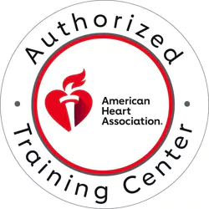
2023 CPR
REGISTRATION FORM
. (non-DPH Employee)

The Heartsaver CPR Class will consist of:
- Learning CPR, relief of choking in adults, children and infants, and AED use for all ages.
- The use of barrier devices is also covered.

NAME: ________________________________________________________________________
HOME ADDRESS: _______________________________________________________________
CITY: ________________________ STATE: ________________ ZIP CODE: ____________
PHONE: _______________________ EMAIL: ________________________________________
There is a charge of $30.00 per student for CPR.
There is a charge of $10.00 per student for BBP certification class. .
MAKE CHECKS PAYABLE TO: RICHMOND COUNTY HEALTH DEPARTMENT.
.
Registration Forms are to be emailed to:
Crystal.Hillman@dph.ga.gov

LOCATION OF CLASS: 1916 NORTH LEG RD, BUILDING I
AUGUSTA, GA 30909
9:00 AM – 11:00 AM

THE PM CLASSES WILL BE 2:00 PM – 4:00 PM (PM CLASSES ARE AS NEEDED ONLY).

IF THERE ARE ANY CHANGES TO THE SCHEDULE (CANCELLATION / TIME OF CLASS / LOCATION OF CLASS) OR IF A PM CLASS IS NEEDED, YOU WILL BE NOTIFIED IN ADVANCE AND WILL BE GIVEN TOP PRIORITY WHEN RESCHEDULING.

Choose your class date:
January 12, 2023 July 6, 2023
February 9, 2023 August 3, 2023
March 9, 2023 September 14, 2023

April 20, 2023 October 26, 2023
May 18, 2023 November 30, 2023
June 8, 2023 NO DECEMBER CLASS

______________________________________________________________________________ Signature Print Name Date

