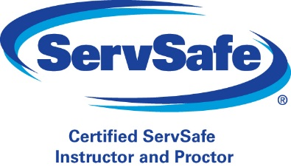
2019 SERVSAFE CLASS REGISTRATION FORM

This course is primarily to certify managers/staff and will require a written examination. A certificate will be issued upon satisfactory completion of the course and will be valid for (5) five years. Registration is complete when your form and fee are received by our office. Your textbook will be provided at registration and should be reviewed prior to class attendance. Registration is completed at 1916 North Leg Rd, Building K, Augusta, GA, 30909. No shows must reschedule within 10 days of the missed class or all fees are forfeited. NO REFUNDS!!! Should you have any questions, please feel free to call our office at (706) 667-4234.

NAME:
FACILITY:
ADDRESS:
CITY: | STATE: |  | ZIP:
EMAIL: |  | PHONE:

FEE(S): _____Class: Includes Book & Exam - $190
_____Class & Exam Only: *No Book - $135
*ServSafe Manager 7th Edition book is required for class _____Book & Exam Only: No Class - $135
_____Book Only - $75
_____Exam Only: Day 2 at 1:45 PM - $75
_____Online Exam (Call for appt.) - $75

PLEASE SELECT A LANGUAGE PREFERENCE FOR PRINTED MATERIALS:
Textbook/Exam: _____English _____Spanish _____Other: __________________
Textbook/Pretest Issued: Yes No Initials: __________

CLASSES: □January 16-17, 2018 □ May 22-23, 2018 □ September 25-26, 2018
□ February 13-14, 2018 □ June 19-20, 2018 □ October 23-24, 2018
□ March 20-21, 2018 □ July 24-25, 2018 □ November 20-21, 2018
□ April 17-18, 2018 □ August 21-22, 2018

LOCATION OF CLASS: Richmond County Health Department
1916 North Leg Rd. Building D
Augusta, GA 30909
TIME: 9 AM TO 5 PM

Please make checks payable to: Richmond County Health Department (RCHD) and mail with your completed registration form to the address above or you may email or fax your registration form and make payment over the phone using a credit/debit card OR register and pay in our office.

________________________________________________________________________________________ Signature Print Name Date

